MINI PROJECT DOCUMENTATION

Student Management System
Artificial Intelligence & Machine Learning
Submitted by
ABISHEK R V
Register No: 922524148003
III Year | B.E – AIML | Batch: 2024–2028
Department of Artificial Intelligence & Machine Learning
Academic Year: 2024 – 2028

Index of Activities & Deliverables

S.No | Planned Activity | Expected Deliverable
1 | Project Title Finalization | Approved Project Title
2 | Requirement Gathering | Problem Statement
3 | Objective Definition | Project Objectives
4 | User & Module Identification | Module List
5 | Use Case Diagram Preparation | Use Case Diagram
6 | Database Requirement Analysis | Table List
7 | ER Diagram Design | ER Diagram
8 | Database Schema Creation | SQL Schema
9 | UI Wireframe Design | Page Layouts
10 | Login & Dashboard UI Design | UI Screens
11 | Navigation & Form Design | UI Prototype
12 | Design Review | Design Approval
13 | Frontend Environment Setup | React Project Setup
14 | Login Page Development | Login Module
15 | Registration Page Dev | Registration Module

01 Project Title Finalization

Approved Project Title
Student Management System (SMS)

Student Details
Field | Details
Student Name | Abishek RV
Register Number | 922524148003
Department | Artificial Intelligence & Machine Learning (AIML)
Year / Batch | III Year — 2024 to 2028
Project Type | Mini Project
Academic Year | 2026 – 2027 (Odd Semester)

Title Justification
The title 'Student Management System' accurately reflects the scope and purpose of this project. The system is designed to digitally manage student records, attendance, course enrollments, grades, and report generation in one unified web-based platform. The title is concise, self-explanatory, and appropriate for a mini project at the third-year AIML level.

02 Requirement Gathering — Problem Statement

Background
Educational institutions today still depend on manual methods such as physical registers, spreadsheets, and paper-based systems to manage student information. These traditional methods are slow, error-prone, and difficult to maintain as student populations grow.
Problem Statement
There is a need for a centralized, secure, and automated web application that replaces manual student record management, reduces data redundancy, supports secure password less login, automates GPA calculation, and enables quick CSV report generation.

Key Problems Identified
Problem | Impact
Manual data entry in registers and Excel sheets | High error rate; data duplication across departments
No centralized student database | Data scattered; difficult to retrieve records quickly
Password-based logins susceptible to phishing | Security risk; forgotten passwords cause access loss
GPA calculation done manually | Inconsistency and errors in academic performance records
Report generation requires manual compilation | Time-consuming; prone to mistakes in final reports
Attendance tracked on paper registers | Loss of records; no historical trend analysis possible
Stakeholders
- College Administrators — manage student records and reports.
- Faculty Members — mark attendance and enter grades.
- Students — view their own profile, attendance, and GPA.

03 Objective Definition — Project Objectives

Primary Objectives
The Student Management System is developed to achieve the following well-defined objectives:
No. | Objective | Outcome
1 | Centralized digital storage of all student records | Eliminates paper registers; single source of truth
2 | Password less OTP-based authentication via email | Secure login; removes password vulnerabilities
3 | Automated GPA calculation from entered marks | Accurate, consistent academic performance tracking
4 | Digital daily attendance tracking per course | Historical records; attendance percentage auto-calculated
5 | Course and department management | Organized academic structure in the database
6 | CSV export of student and grade reports | Quick data sharing; replaces manual compilation
7 | Real-time Admin Dashboard with KPI statistics | Instant overview of institutional data

Secondary Objectives
- Provide a responsive and user-friendly UI using Bootstrap 5 and React.
- Ensure data integrity through proper database relationships and constraints.
- Make the codebase modular and maintainable for future enhancement.
- Follow Django's MVT architecture for clean separation of concerns.

04 User & Module Identification — Module List

System Users
User Role | Access Level | Key Actions
Administrator | Full Access | Manage all modules: students, courses, attendance, grades, reports
Faculty | Limited Access | Mark attendance, enter grades for assigned courses
Student | Read-Only Access | View own profile, attendance percentage, and GPA

Module Breakdown
Module 1 — Authentication
Custom User model with OTP generation, Gmail SMTP email delivery, session management, and logout functionality.
Module 2 — Student Management
Full CRUD operations for student profiles including photo upload, search by name or roll number, and department-wise filter.
Module 3 — Department & Course Management
Add, edit, and delete academic departments and their associated courses with credit hours.
Module 4 — Attendance Module
Daily attendance marking (Present / Absent / Late) per course, historical view, and automatic attendance percentage calculation.
Module 5 — Grade & Performance Module
Marks entry per Enrollment, automatic letter grade assignment, and GPA calculation using weighted average formula.
Module 6 — Reports Module
Export student list, attendance records, and grade reports as downloadable CSV files.
Module 7 — Admin Dashboard
KPI cards showing live counts (Total Students, Courses, Departments, Enrollments) and a recent admissions table.

05 Use Case Diagram Preparation

Use Case Diagram — Student Management System
The following diagram illustrates how each actor (Administrator, Faculty, Student) interacts with the system's functional use cases.

«Actor» | Student Management System — System Boundary | «Actor»
👤  Administrator | ( Login via OTP )  ( Manage Students — CRUD )  ( Manage Departments & Courses )  ( Mark / View Attendance )  ( Enter Marks & View GPA )  ( Generate CSV Reports )  ( View Admin Dashboard )  ( Manage Faculty Accounts ) | 👤  Faculty / Student  (Limited Access)

Actor — Use Case Mapping
Actor | Use Cases
Administrator | Login, Manage Students, Manage Courses/Departments, Mark Attendance, Enter Grades, Generate Reports, View Dashboard
Faculty | Login, Mark Attendance for assigned courses, Enter Marks for assigned subjects
Student | Login, View own Profile, View own Attendance, View own GPA and Grades
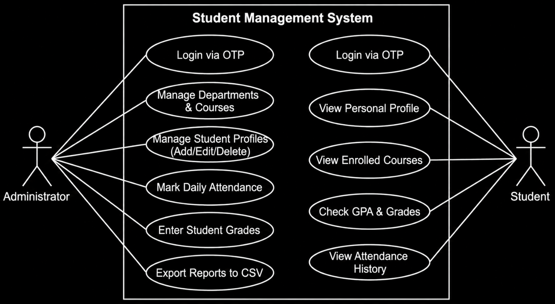

06 Database Requirement Analysis — Table List

Database Overview
The system uses SQLite3 (via Django ORM) as the database engine. The following seven tables store all application data. Each table is designed to avoid redundancy and maintain referential integrity.

Table Name | Primary Key | Key Fields | Linked To
CustomUser | id (Auto) | email, otp, otp_expiry, is_staff | —
Department | id (Auto) | name, code, description | —
Course | id (Auto) | name, code, credits, department_id | Department
Student | id (Auto) | full_name, roll_no, email, photo, dept_id | Department
Enrollment | id (Auto) | student_id, course_id, enrolled_on | Student, Course
Grade | id (Auto) | enrollment_id, marks, letter_grade, gpa | Enrollment
Attendance | id (Auto) | student_id, course_id, date, status | Student, Course

Table Descriptions
CustomUser
Stores login credentials. Extends Django's AbstractBaseUser. Uses email as USERNAME_FIELD. OTP and its expiry timestamp are stored here for the passwordless login flow.
Department
Stores academic department details. Each department has a unique short code (e.g., AIML, CSE, ECE).
Course
Stores course offerings. Each course belongs to one department via a Foreign Key. Includes credit hours.
Student
Core entity. Stores student personal information including photo upload. Linked to Department.
Enrollment
Junction table linking a Student to a Course. Has a unique constraint on (student_id, course_id) to prevent duplicate enrollments.
Grade
One-to-one relationship with Enrollment. Stores marks, letter grade, and computed grade point.
Attendance
Stores one record per (student, course, date) with status: Present, Absent, or Late.

07 ER Diagram Design — Entity Relationship Diagram

Entities and Relationships
The ER Diagram below shows all seven entities, their key attributes, and the relationships between them. PK = Primary Key, FK = Foreign Key.

DEPARTMENT  PK id  nae  code (unique)  description | 1  ────── has ──────  N | COURSE  PK id  name  code (unique)  credits  FK department_id
│ 1  │ has  │ N | CUSTOMUSER  PK id  email (unique)  is_staff  otp  otp_expiry
STUDENT  PK id  full_name  roll_number (unique)  email (unique)  dob  photo  FK department_id | ──── 1 : N ────▶ ENROLLMENT  ENROLLMENT  PK id  FK student_id  FK course_id  enrolled_on  UNIQUE(student, course)  │ 1 : 1  ▼  GRADE  PK id  FK enrollment_id (unique)  marks  letter_grade  grade_point

STUDENT ──── 1:N ────┐  │ | ATTENDANCE  PK id  FK student_id  FK course_id  date  status (P/A/L) | ┌──── N:1 ──── COURSE  │

Relationship Summary
From | Relationship | To | Type
Department | has | Course | 1 : N
Department | has | Student | 1 : N
Student | enrolls in | Enrollment | 1 : N
Course | part of | Enrollment | 1 : N
Enrollment | has | Grade | 1 : 1
Student | has | Attendance | 1 : N
Course | tracked by | Attendance | 1 : N
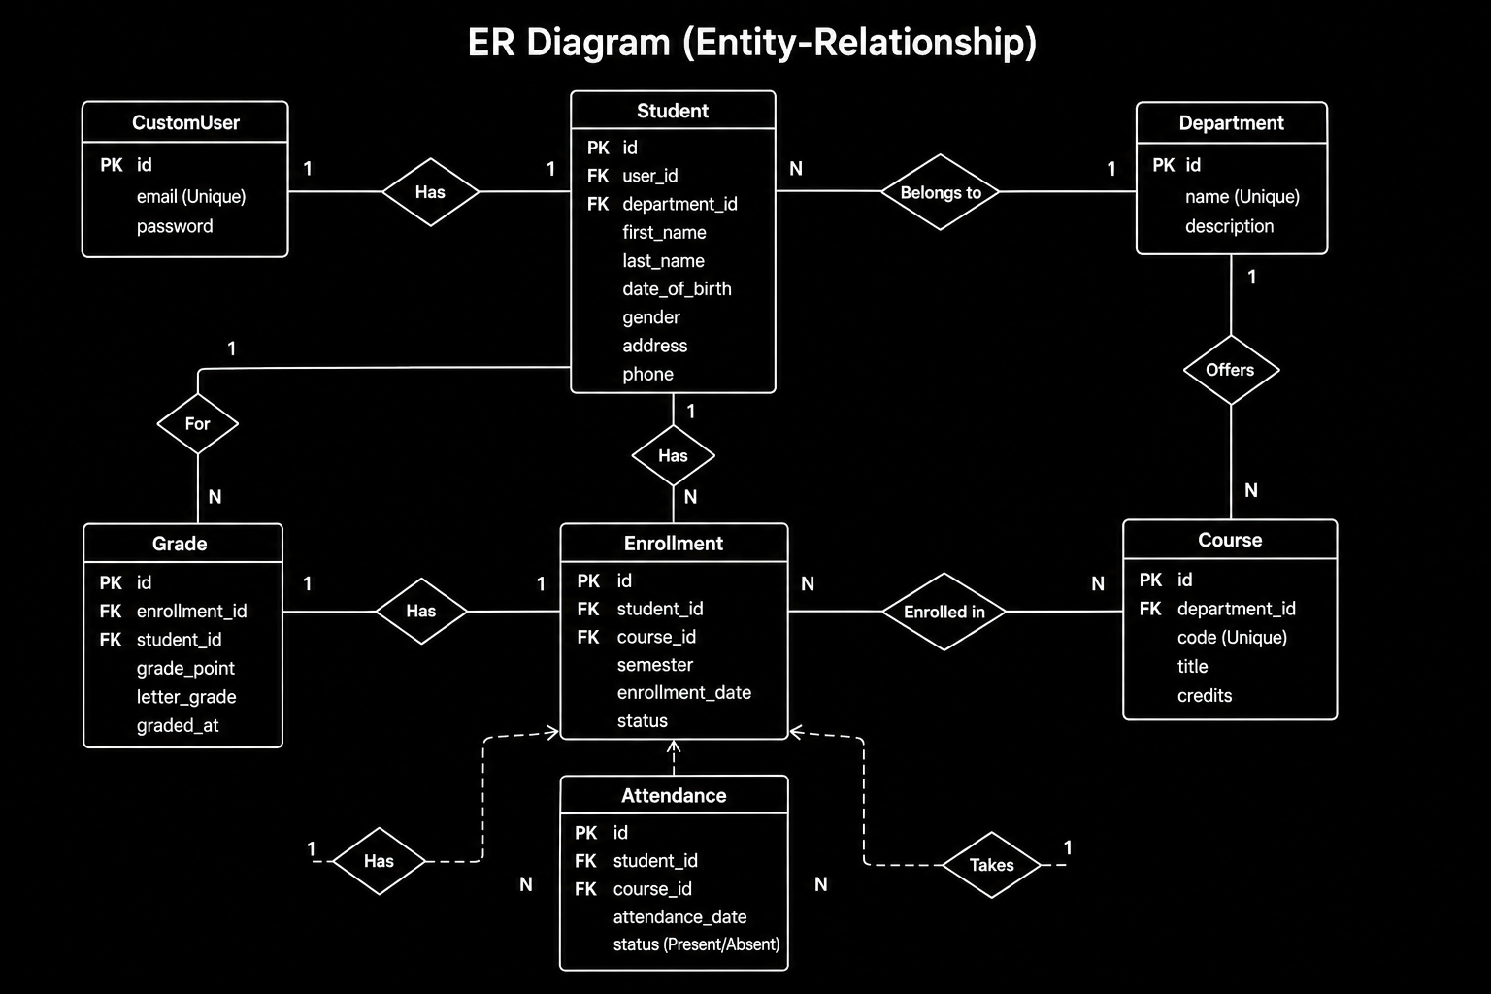

08 Database Schema Creation — SQL Schema

CREATE TABLE Statements
The following SQL schema is auto-generated by Django's migration system. It reflects all models defined in models.py.

-- =============================================
-- Student Management System — SQLite3 Schema
-- Generated via Django ORM Migrations
-- =============================================
CREATE TABLE auth_customuser (
id INTEGER PRIMARY KEY AUTOINCREMENT,
email VARCHAR(254) UNIQUE NOT NULL,
is_active BOOLEAN NOT NULL DEFAULT 1,
is_staff BOOLEAN NOT NULL DEFAULT 0,
otp VARCHAR(6),
otp_expiry DATETIME
);
CREATE TABLE sms_department (
id INTEGER PRIMARY KEY AUTOINCREMENT,
name VARCHAR(100) NOT NULL,
code VARCHAR(10) UNIQUE NOT NULL,
description TEXT
);
CREATE TABLE sms_course (
id INTEGER PRIMARY KEY AUTOINCREMENT,
name VARCHAR(150) NOT NULL,
code VARCHAR(10) UNIQUE NOT NULL,
credits INTEGER NOT NULL DEFAULT 3,
department_id INTEGER REFERENCES sms_department(id)
);
CREATE TABLE sms_student (
id INTEGER PRIMARY KEY AUTOINCREMENT,
full_name VARCHAR(150) NOT NULL,
roll_number VARCHAR(20) UNIQUE NOT NULL,
email VARCHAR(254) UNIQUE NOT NULL,
dob DATE,
photo VARCHAR(200),
department_id INTEGER REFERENCES sms_department(id)
);
CREATE TABLE sms_enrollment (
id INTEGER PRIMARY KEY AUTOINCREMENT,
student_id INTEGER REFERENCES sms_student(id) ON DELETE CASCADE,
course_id INTEGER REFERENCES sms_course(id) ON DELETE CASCADE,
enrolled_on DATE NOT NULL,
UNIQUE (student_id, course_id)
);
CREATE TABLE sms_grade (
id INTEGER PRIMARY KEY AUTOINCREMENT,
enrollment_id INTEGER UNIQUE REFERENCES sms_enrollment(id) ON DELETE CASCADE,
marks DECIMAL(5,2),
letter_grade VARCHAR(2),
grade_point DECIMAL(3,2)
);
CREATE TABLE sms_attendance (
id INTEGER PRIMARY KEY AUTOINCREMENT,
student_id INTEGER REFERENCES sms_student(id) ON DELETE CASCADE,
course_id INTEGER REFERENCES sms_course(id) ON DELETE CASCADE,
date DATE NOT NULL,
status VARCHAR(1) NOT NULL -- 'P'=Present 'A'=Absent 'L'=Late
);

09 UI Wireframe Design — Page Layouts

Design System
Element | Value | Purpose
Primary Color | #1A2E4A (Navy Blue) | Headers, navbar, section banners
Accent Color | #0D7377 (Teal) | Buttons, links, active states
Background | #F4F6F9 (Light Gray) | Page background, alternate table rows
Font Family | Inter / Calibri | Clean readability across devices
Grid System | Bootstrap 5 (12-col) | Responsive layout for all screen sizes
Icon Library | Bootstrap Icons 1.x | Consistent icon set

Page Layout Descriptions
1. OTP Request Page
Centered card (max-width 420px) on a gray background. Contains: college logo at top, heading 'Login to SMS', email input field with placeholder, and a primary 'Send OTP' button. A short instruction line explains the passwordless process.
2. OTP Verify Page
Same card layout as request page. Contains a 6-digit OTP input (large font for readability), a countdown timer showing remaining validity (10:00 minutes), a 'Verify OTP' button, and a 'Resend OTP' link (enabled after 60 seconds).
3. Admin Dashboard
Full-width layout with fixed top navbar and left sidebar. Top row: 4 KPI stat cards in Bootstrap grid (Total Students, Courses, Departments, Enrollments) with icons and count values. Below: a 'Recent Admissions' table showing the last 5 students, and 4 quick-action buttons to each module.
4. Student List Page
Table view with columns: Roll No, Full Name, Department, Email, Actions (Edit / Delete / View). Top bar has a search input and 'Add Student' button. Pagination at the bottom. Department filter dropdown on the right.
5. Student Profile Page
Two-column layout: left column shows student photo (rounded), name, roll number, email, and department. Right column shows three tabs — Enrollment & Grades (GPA summary table), Attendance (percentage bar per course), and Edit Profile button.

10 Login & Dashboard UI Design — UI Screens

Login UI — OTP Flow Screens
[ College Logo ]  Login to SMS  Enter your registered no...  Send OTP  Screen 1: OTP Request | [ College Logo ]  Verify OTP  OTP sent to user@email.com  [ _ ] [ _ ] [ _ ] [ _ ]  [ _ ] [ _ ]  ⏱ Expires in: 05:00  Verify OTP  Screen 2: OTP Verify

Admin Dashboard UI
🏠 Student Management System | [Students] [Courses] [Attendance] [Grades] [Reports] [Logout]
[ 248 Students ] [ 32 Courses ] [ 6 Departments ] [ 710 Enrollments ]

Recent Admissions
Roll No | Name | Dept | Date
CS24001 | Abishek RV | AIML | 01-Jul-2024
CS24002 | Priya S | CSE | 01-Jul-2024

11 Navigation & Form Design — UI Prototype

Application Navigation Flow
The following structured flow diagram shows how a user moves through the application from login to each functional module:

STEP 1 OTP Request Page → User enters registered email → Click 'Send OTP'
↓ OTP email delivered to inbox via Gmail SMTP
STEP 2 OTP Verify Page → Enter 6-digit code → Click 'Verify OTP'
↓ If OTP is correct & not expired → Session created
STEP 3 Admin Dashboard → KPI Cards + Recent Admissions Table
↓ Choose any module from top navbar or sidebar
Module Navigation from Dashboard

├─ 📋 Students → List → Add / Edit / Delete / Profile
├─ 🏫 Departments → List → Add / Edit
├─ 📚 Courses → List → Add / Edit
├─ ✅ Attendance → Mark Attendance → View History
├─ 📊 Grades → Enter Marks → View GPA Report
└─ 📥 Reports → Export Students CSV / Export Grades CSV
LOGOUT → Session cleared → Redirect back to OTP Request Page

Key Forms in the Prototype
Form | Fields | Validation
Add Student Form | Full Name, Roll No, Email, DOB, Department, Photo | Required fields; unique roll no & email; image format check
Mark Attendance Form | Course, Date, Student list with P/A/L radio buttons | All students must have a status selected before submit
Grade Entry Form | Student, Course, Marks (0–100) | Marks must be numeric, between 0 and 100
OTP Request Form | Email address | Must be a registered email in the system
Add Course Form | Course Name, Code, Credits, Department (dropdown) | Unique course code; credits must be a positive integer

12 Design Review — Design Approval

Design Review Summary
A structured design review was conducted to evaluate the UI/UX decisions made during wireframing and prototype stages. The following criteria were assessed:
Review Criteria | Decision | Approved
Color Theme | Primary Navy #1A2E4A; Accent Teal #0D7377 — professional and readable | ✅ Yes
Typography | Inter / Calibri at 14px body — clean and legible on all screen sizes | ✅ Yes
Responsive Layout | Bootstrap 5 12-column grid — tested on desktop, tablet, and mobile | ✅ Yes
Form Design | Inline error messages, required field indicators, and confirmation dialogs | ✅ Yes
Navigation UX | Sticky top navbar + sidebar; breadcrumbs on inner pages | ✅ Yes
Accessibility | Sufficient color contrast; labels on all form inputs; keyboard navigation | ✅ Yes
Consistency | Same card style, button style, and table design used across all pages | ✅ Yes
Loading Feedback | Spinner shown on OTP send and form submit to prevent double clicks | ✅ Yes

Final Design Approval Statement
The UI/UX design for the Student Management System has been reviewed and approved. All page layouts, the navigation flow, the color theme, and the form designs meet the standards required for a college mini project. The design is consistent, accessible, and suitable for the intended users.

Sign-off
Role | Name | Signature | Date
Student | Abishek RV | _______________ | ___/___/2025
Project Guide | Prof. ____________ | _______________ | ___/___/2025
HOD | Dr. _____________ | _______________ | ___/___/2025

13 Frontend Environment Setup — React Project Setup

Technology Stack
Layer | Technology | Version | Purpose
Frontend Framework | React.js | 18.x | Component-based UI development
Styling | Bootstrap 5 | 5.3 | Responsive grid and pre-built components
HTTP Client | Axios | 1.x | API calls to Django REST backend
Routing | React Router | 6.x | Client-side page navigation (SPA)
State Management | React useState | — | Local component state (no Redux needed)
Build Tool | Vite | 5.x | Fast development server and bundler
Package Manager | npm / yarn | — | Dependency management

Project Setup Commands
# Step 1: Create React app using Vite
npm create vite@latest sms-frontend -- --template react
cd sms-frontend
# Step 2: Install dependencies
npm install
npm install axios react-router-dom bootstrap
# Step 3: Import Bootstrap in main.jsx
// Add to src/main.jsx:
import 'bootstrap/dist/css/bootstrap.min.css';
# Step 4: Start development server
npm run dev
# Runs on http://localhost:5173
# Step 5: Django CORS setup (for API calls)
pip install django-cors-headers
# Add to settings.py INSTALLED_APPS:
# 'corsheaders'
# Add to MIDDLEWARE:
# 'corsheaders.middleware.CorsMiddleware'
# Add:
# CORS_ALLOWED_ORIGINS = ['http://localhost:5173']

Project Folder Structure — React
sms-frontend/
├── public/
│ └── logo.png
├── src/
│ ├── main.jsx # Entry point
│ ├── App.jsx # Router setup
│ ├── api/
│ │ └── axios.js # Axios base URL config
│ ├── components/
│ │ ├── Navbar.jsx
│ │ ├── Sidebar.jsx
│ │ └── KpiCard.jsx
│ └── pages/
│ ├── LoginPage.jsx
│ ├── VerifyOtp.jsx
│ ├── Dashboard.jsx
│ ├── StudentList.jsx
│ └── StudentProfile.jsx
└── vite.config.js

14 Login Page Development — Login Module

OTP Login Workflow
Step | Action | Django Backend | React Frontend
1 | User enters email | — | Controlled input with useState
2 | Click 'Send OTP' | POST /auth/request-otp/ | axios.post() — show loading spinner
3 | OTP generated & emailed | Generate 6-digit OTP, store + send mail | Show success toast notification
4 | User enters OTP code | — | 6-input fields with auto-focus next
5 | Click 'Verify OTP' | POST /auth/verify-otp/ | axios.post() with OTP value
6 | OTP matched & not expired | Create session, return 200 OK | Save token to localStorage, redirect
7 | Invalid / expired OTP | Return 400 error message | Show inline error, highlight field red

React Code — OTP Request Page
// src/pages/LoginPage.jsx
import { useState } from 'react';
import axios from '../api/axios';
import { useNavigate } from 'react-router-dom';
export default function LoginPage() {
const [email, setEmail] = useState('');
const [error, setError] = useState('');
const [loading, setLoading] = useState(false);
const navigate = useNavigate();
const handleSendOTP = async () => {
setLoading(true);
try {
await axios.post('/auth/request-otp/', { email });
navigate('/verify-otp', { state: { email } });
} catch (err) {
setError('Email not registered. Please contact admin.');
} finally {
setLoading(false);
}
};
return (
<div className='d-flex justify-content-center align-items-center vh-100 bg-light'>
<div className='card shadow p-4' style={{ maxWidth: 420 }}>
<h4 className='text-center mb-3'>Login to SMS</h4>
<input type='email' className='form-control mb-2'
placeholder='Enter your email'
value={email} onChange={e => setEmail(e.target.value)} />
{error && <div className='text-danger small mb-2'>{error}</div>}
<button className='btn btn-primary w-100' onClick={handleSendOTP}
disabled={loading}>
{loading ? 'Sending...' : 'Send OTP'}
</button>
</div>
</div>
);
}

15 Registration Page Development — Registration Module

Registration Module Overview
The Registration Module allows administrators to add new students to the system. It includes form validation, photo upload, department selection, and real-time error feedback.
Form Fields & Validation Rules
Field | Input Type | Validation Rule
Full Name | Text input | Required; minimum 2 characters; letters only
Roll Number | Text input | Required; must be unique in the database
Email Address | Email input | Required; valid email format; must be unique
Date of Birth | Date picker | Required; must be at least 16 years ago
Department | Dropdown | Required; must select from existing departments
Profile Photo | File upload | Optional; accepted formats: JPG, PNG; max 2 MB

React Code — Add Student Form
// src/pages/AddStudent.jsx
import { useState, useEffect } from 'react';
import axios from '../api/axios';
import { useNavigate } from 'react-router-dom';
export default function AddStudent() {
const [form, setForm] = useState({
full_name: '', roll_number: '', email: '',
dob: '', department: '', photo: null
});
const [departments, setDepartments] = useState([]);
const [errors, setErrors] = useState({});
const navigate = useNavigate();
useEffect(() => {
axios.get('/departments/').then(r => setDepartments(r.data));
}, []);
const handleChange = e => {
const { name, value, files } = e.target;
setForm(f => ({ ...f, [name]: files ? files[0] : value }));
};
const handleSubmit = async () => {
const data = new FormData();
Object.entries(form).forEach(([k, v]) => v && data.append(k, v));
try {
await axios.post('/students/add/', data,
{ headers: { 'Content-Type': 'multipart/form-data' } });
navigate('/students');
} catch (err) {
setErrors(err.response?.data || {});
}
};
return (
<div className='container mt-4'>
<h4>Add New Student</h4>
<div className='row g-3'>
{['full_name','roll_number','email','dob'].map(field => (
<div className='col-md-6' key={field}>
<label className='form-label'>{field.replace('_',' ')}</label>
<input name={field} className='form-control'
type={field==='dob'?'date':'text'}
onChange={handleChange} />
{errors[field] && <div className='text-danger small'>{errors[field]}</div>}
</div>
))}
<div className='col-md-6'>
<label className='form-label'>Department</label>
<select name='department' className='form-select' onChange={handleChange}>
<option value=''>-- Select Department --</option>
{departments.map(d => <option key={d.id} value={d.id}>{d.name}</option>)}
</select>
</div>
<div className='col-md-6'>
<label className='form-label'>Profile Photo</label>
<input name='photo' type='file' className='form-control'
accept='image/*' onChange={handleChange} />
</div>
<div className='col-12'>
<button className='btn btn-success' onClick={handleSubmit}>
Save Student
</button>
</div>
</div>
</div>
);
}

